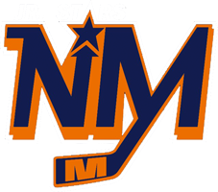
NORTH MIDDLESEX DISTRICT MINOR HOCKEY ASSOCIATION
2020 IP Jamboree
- Date: Friday, January 24, 2020
- Entry Fee: $400 per team
- Teams will be divided into 2 tiered divisions based on skill level determined by their coach at the time of registration (A being higher calibre, B being lower calibre)
- Each team will play a quantity of 3 40-minute games.
- Following the first game, each team will participate in a 15-minute skills competition.
- North Middlesex YMCA will be providing an additional activity for players between games.
- Lunch for players is included in the entry fee.
- Registration will be confirmed once your payment has been received.
O.M.H.A. Sanction #9589
Cheques to be made payable to: N.M.D.M.H.A
Registration form, O.M.H.A team roster and copy of travel permit be sent to:
Courtney Rees
34739 Creamery Rd
Ailsa Craig, ON
N0M 1A0
Team Name: | Manager Name:
Home Branch: | Manager Email Address:
Divison (A/B): | Manager Contact Number:
Head Coach Name: | Head Coach Contact Number:

