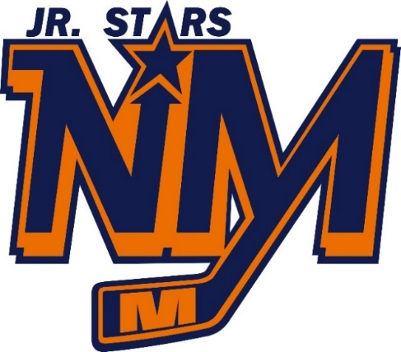
WING NIGHT
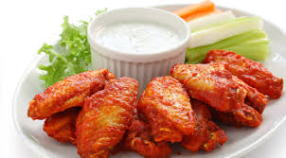
Friday, December 14, 2018
6:30pm – 9:30pm
North Middlesex Arena @ the Goal Post
Adults $10 (for 10 Wings)
10 and under $5 (for 5 wings and juice box)

Silent Auction Table

Come on out and support your local hockey teams!

Schedule & more info at
Northmiddlesexhockey.com

